

**Fashion designer**

Worked by Ing. Lada Kutějová

**1. THEORETICAL PART**

Describe the picture.

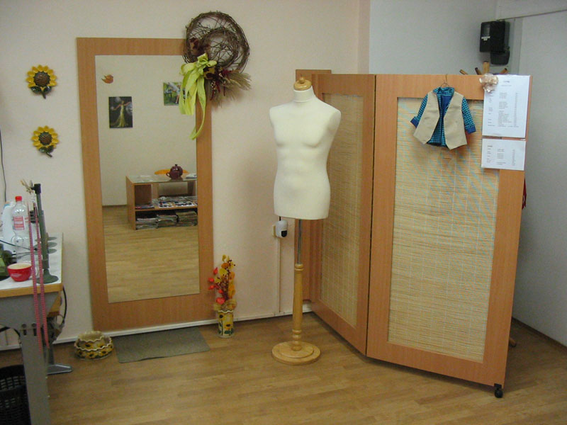

In the picture there is ……

**2. WRITING**

Write 60 words about your lifestyle. What do you like wearing? Who is your favourite fashion designer and why?