Worksheet
CONTESTS, TRAINEESHIP, VOCATIONAL ACTIVITIES, SCHOOL ACADEMY, INTERNATIONAL RELATIONS – PHOTOGRAPHERS

6.1 CONTESTS

6.1.1 Choose the correct answer. Only one is correct.
1. Your favourite radio says about a contest. You want to join in. What do you say?
a. I´m going to win b. I will win c. I´m winning

2. When you want to join, you need to ask for a(n):
a. application form b. winner´s form c. prescription

3. Now you are the winner. What do you say?
a. I win! b. I´ll win! c. I´ve won!

6.1.2 Fill in the application form for a photo contest.
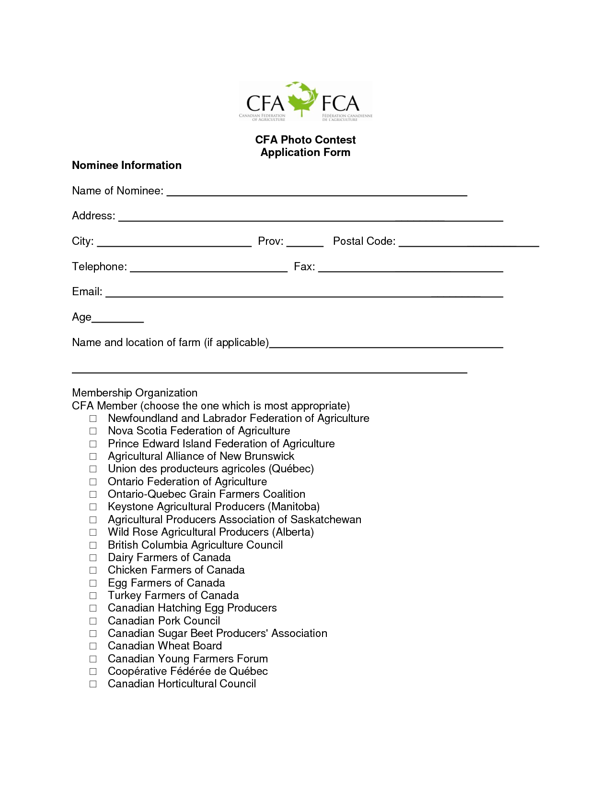

WORKSHEET
CONTESTS, TRAINEESHIP, VOCATIONAL ACTIVITIES, SCHOOL ACADEMY, INTERNATIONAL RELATIONS – PHOTOGRAPHERS

6.2 Traineeship

6.2.1 True or false?
a. Traineeship abroad is for the best students only. ___
b. Traineeship only takes place abroad. ___
c. There is always one student only in the traineeship. ___
d. Traineeship is a great opportunity. ___

6.2.2 a. Can you think of five advantages of a traineeship abroad?
______________
______________
______________
______________
______________

b. Can you think of any disadvantages of a traineeship abroad?
______________
______________
______________
______________
______________

6.2.3 What do you need to do/be to go to a traineeship abroad? Discuss with the class.
______________
______________
______________
______________
______________

WORKSHEET
CONTESTS, TRAINEESHIP, VOCATIONAL ACTIVITIES, SCHOOL ACADEMY, INTERNATIONAL RELATIONS – PHOTOGRAPHERS
6.3. Vocational Training – Work with clients
  - Multiple choice. Choose the correct answer. More answers may be correct!
- What we do at vocational training:
1. learn how to take pictures 2. how to process films 3. how to work with a camcorder

- A client may make you feel uncomfy because s/he makes:
1. nice comments 2. rude comments 3. Violent reactions

- In uncomfortable situations when the client does not agree, the photographer:
- is a professional and he can explain the situation.
- takes it personally and is rude.

  - Describe a possible client:
1. Positive characteristic 2. Negative characteristic
____________________ ____________________
____________________ ____________________
____________________ ____________________

  - Your client is not happy with the photos you have made. How can you solve the situation?

  - Discuss these questions with your partner and then work as a whole class.

- What are general ´green´ rules?
___________________ ___________________
___________________ ___________________
___________________ ___________________

- What waste can you separate?
___________________ ___________________
___________________ ___________________
___________________ ___________________

- Do you know something about ecological washing?
___________________ ___________________
___________________ ___________________
___________________ ___________________

- Which means of transport is more ecological? Which are less ecological?
___________________ ___________________
___________________ ___________________

WORKSHEET
CONTESTS, TRAINEESHIP, VOCATIONAL ACTIVITIES, SCHOOL ACADEMY, INTERNATIONAL RELATIONS – PHOTOGRAPHERS

6.4. SCHOOL ACADEMY

6.4.1 You have only one task for this lesson.
Make your own plan of a school academy. What would it look like if you could organize it? Discuss in groups, then possibly in the class. Prepare quite a detailed schedule.

Think of things such as:
    - theme
    - participants
    - form
    - linking
    - financial matters
    - publicity

WORKSHEET
CONTESTS, TRAINEESHIP, VOCATIONAL ACTIVITIES, SCHOOL ACADEMY, INTERNATIONAL RELATIONS – PHOTOGRAPHERS

6.5 INTERNATIONAL RELATIONS
6.5.1 There have been two EU programmes for our students to go abroad. Do you know anything about them? What do you know? Discuss with the class.
______________________
______________________

6.5.2 How can you join the programmes?

6.5.3 Would you like to join them? Why? What are the positives of such projects? Are there any negatives?
____________________ ____________________
____________________ ____________________
____________________ ____________________

6.5.4 Which countries would you like to visit in such programmes?

6.5.5 How many EU member states are there? Can you name them? (And do you know the capitals?)

